* Respondents Details of Employers Registrations: <https://docs.google.com/spreadsheets/d/1stD5hNzX4xSiFUhorNKmmQEWwRsorwHGVa4yMg-K8t0/edit?usp=sharing>
* Job Utsob Session Matrix: <https://docs.google.com/spreadsheets/d/1iITFiN73rytg0PzVS86aVtJehaOF2qQz/edit?usp=sharing&ouid=101436145636072948692&rtpof=true&sd=true>
* DIU Job Utsob-2022 Facebook Link: [**https://facebook.com/events/s/diu-job-utsob-2022/3397614500467801/**](https://facebook.com/events/s/diu-job-utsob-2022/3397614500467801/)

**01-03 December 2022|Daffodil Smart City (DSC) Campus   
Daffodil International University (DIU)  
Ashulia, Savar, Dhaka-1341, Bangladesh**.

The Idea:

DIU JOB UTSOB -2022 is set to be the ‘Big Bang Central Career Event’ of Daffodil International University and will act as a platform for corporate stalwarts to interact with a quality future workforce under the Daffodil family’s constant intent to encourage, facilitate and sustain industry-academia collaborations.

The program, with its motivation as the tagline- ‘Connecting Talents: Unlock the Border of Opportunities’, looks forward to having a sustainable impact with the presence of freshers, highly skilled job seekers, interns/learners & experienced alumni network interested to make job transitions, recruiters and corporate Leaders, employers, and institutions, ’.

For further details of the event, please visit the official page of DIU Job Utsob-2022

http: //jobutsob.daffodilvarsity.edu.bd

**MESSAGE FROM DIU MANAGEMENT**  
With a tremendously successful track record of ‘On-Campus Spot Recruitment’ events, ‘DIU job Utsob’ shall continue to be a regular yearly event with an aim to develop an understanding of the internship and employment needs largely in the area of corporate and the academia.

DIU Job Utsob-2022 can be considered as the *“meet-up point”* for addressing all that is needed and all that could be achieved through a shared lane of vision between the employers and the bodies involved with creating employees, changemakers, and future industry leaders. The event shall ensure the presence of talents & employers under a roof where the *“Transition in career”* is always heavily inspired.  
  
We believe in a strong spirit of collaboration between academia and industry and we will always cherish the relationship as being fundamental to our coexistence and collective success. To further strengthen and forge this symbiotic relationship, Daffodil International University (DIU) has envisioned a common platform - DIU Job Utsob. This shall be an interesting opportunity where the respective industry representatives get to interact closely with our students and graduates with an intent to hire their potential employees, changemakers, and future leaders of respective departments. We look forward to your active participation and support as always. ”

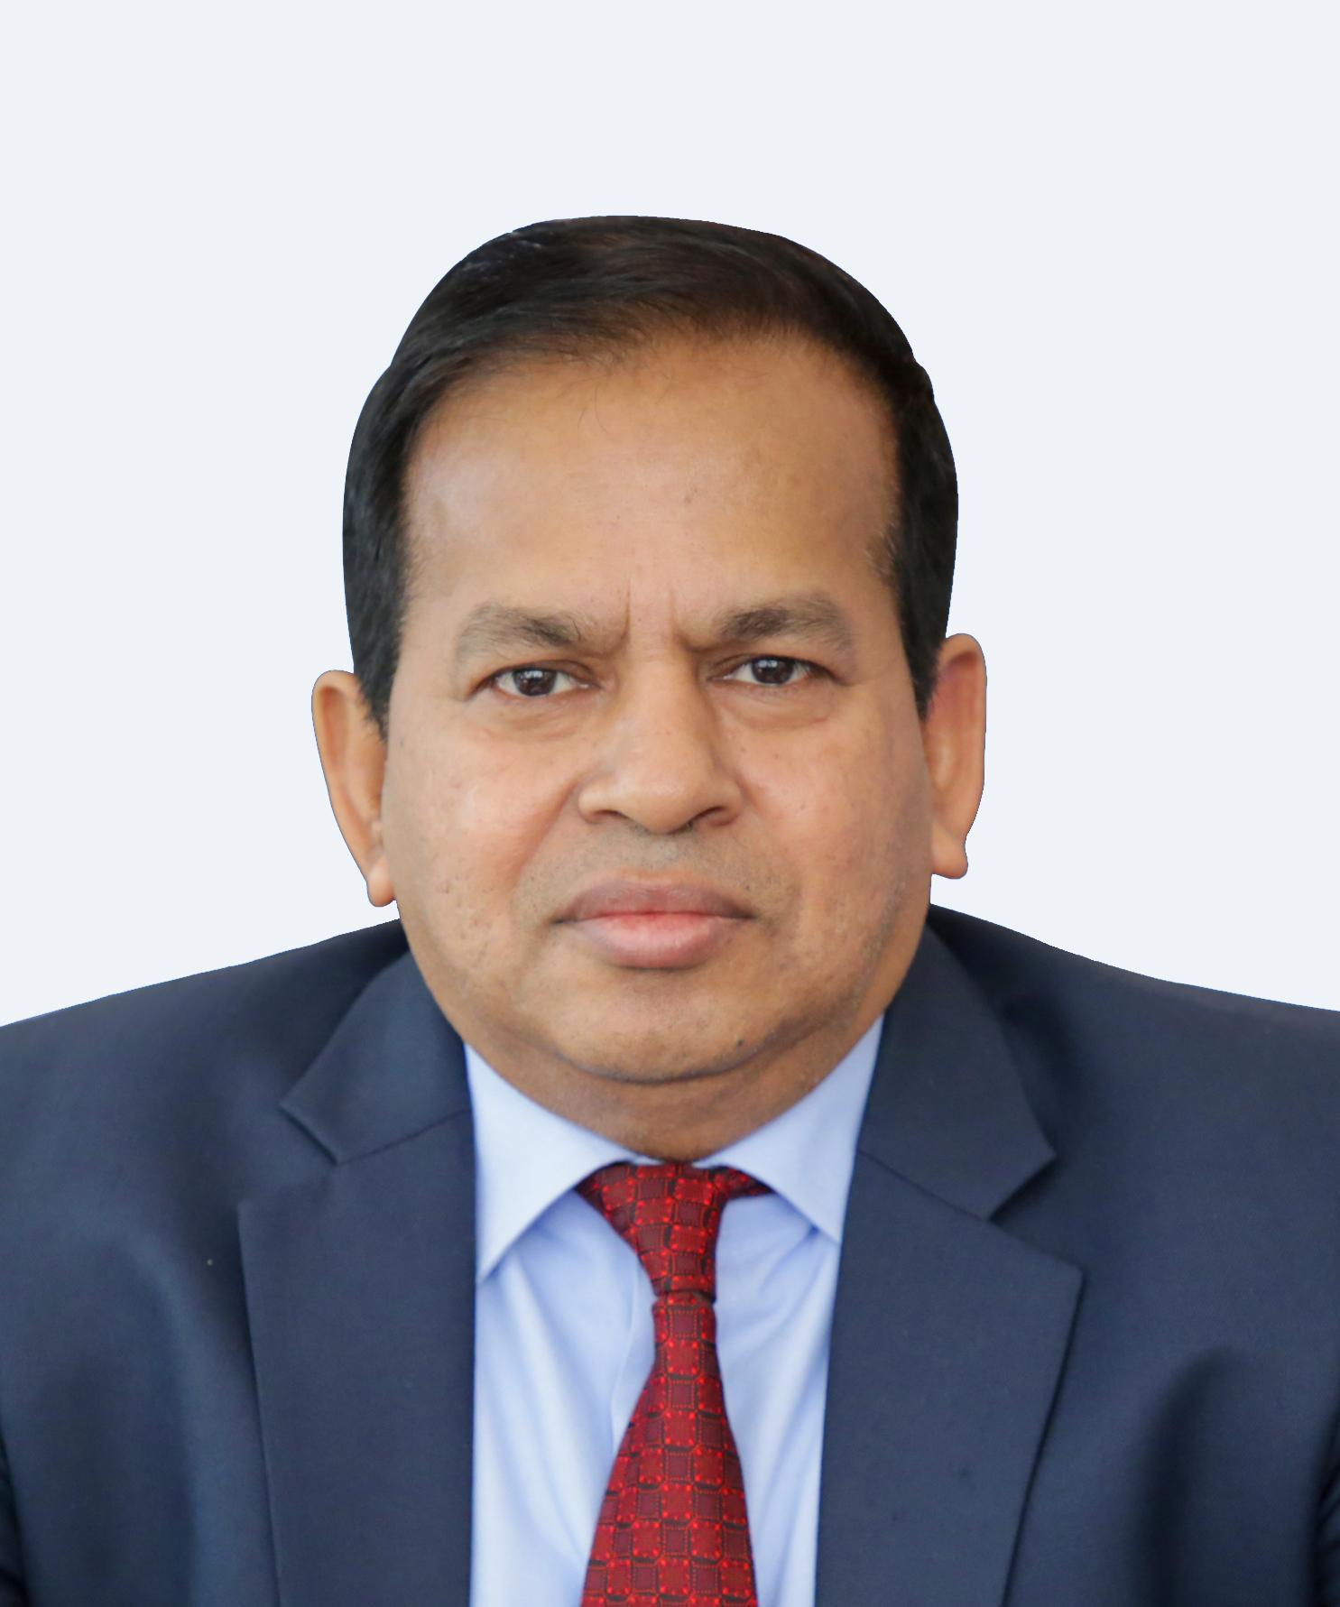

**Prof Dr. M. Lutfar Rahman Prof. Dr. S.M. Mahbub Ul Haque Majumder** [**Prof. Dr. Mostafa Kamal**](http://faculty.daffodilvarsity.edu.bd/profile/bba/mkamal.html)

**Vice Chancellor,DIU Pro Vice Chancellor , DIU Dean,Academic Affairs,DIU**

**ABOUT THE FLAGSHIP EVENT OF ‘DIU JOB UTSOB-2022’***With a tremendously successful track record of ‘On-Campus Spot Recruitment’ events, it is our privilege hosting ‘DIU job Utsob’ for the year 2022.*  
  
DIU Job Utsob-2022 is the annual ‘Big bang career event’ held by the Career Development Center (CDC) of Daffodil International University. The program aims to provide a platform for DIU graduates to connect with the leading and constantly expanding companies of their preferences, and for the corporate sector- an opportunity to recruit interns and employees possessing a suitable career profile.

This event shall showcase how combined efforts of the corporate and academic worlds can optimize the process of building bona fide future leaders for the ever-changing landscape of the Bangladeshi economy, where our future leaders are inspired through “Transition in Career”.This year, the event shall be organized under the tagline- ‘Connecting Talents: Unlock the Border of Opportunities’.

About 200+ reputed companies from 35 industries are expected to take part in this auspicious event. Moreover, this event will effectively open the gateway for companies to meet not only DIU graduates but also its experienced alumni network that is looking forward to making job transitions. We also believe that DIU Job Utsob-2022 will be the perfect platform to find the most suitable candidates for the organizations.

# 

# 

# 

# WHO CAN EXHIBIT/SHOWCASE?

* Employers (private and public) from all sectors (NGOs, Bank, and Financial Institutions, IT/ITES, Multinational companies, Telecom, Local Group of Companies, FMCG, MNC, RMG, Leather, Startup, etc.)
* Placement agencies
* Head-hunting agencies
* Education and training institutions
* Government and other non-Government organizations.



# 

# 

# OUR VALUED EMPLOYERS

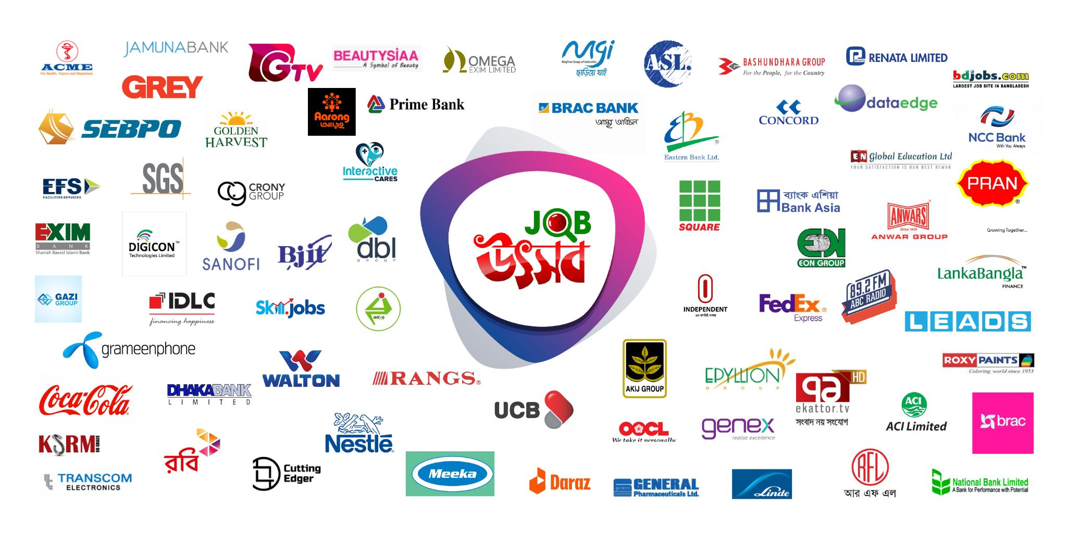

**Job Industry Segment of DIU Job Utsob-2022**

| **SL** | **SELECTED JOB INDUSTRY  DIU JOB UTSOB-2022** | **SL** | **SELECTED JOB INDUSTRY  DIU JOB UTSOB-2022** |
| --- | --- | --- | --- |
| 1 | Local Group of Companies | 19 | ISP & Network Solutions |
| 2 | First moving Consumer Goods (FMCGS) | 20 | E-commerce |
| 3 | Multinational Companies (MNCs) | 21 | Telco & Mobile Phone Operators |
| 4 | Bank/Insurance/Leasing ,Banking/Financial Services | 22 | Law/Legal Services |
| 5 | CNF, Courier and Freight Forwarding Organization | 23 | NGO/Development /Social Services/ Foundation /Club / Association |
| 6 | Non Banking Financial Institutes | 24 | Polymer/Plastic/Rubber |
| 7 | Consulting(Business & Management)/Consultancy | 25 | Power and Energy |
| 8 | Education , Training & Development | 26 | Printing/Publishing |
| 9 | RMG (Garments & Textiles) | 27 | Advertising/Marketing/Promotion/PR/Media/Arts/Communication/Event Management |
| 10 | Pharmaceuticals | 28 | Paints Industry |
| 11 | Food & Beverage/Restaurant | 29 | Property/Real Estate |
| 12 | Hotel, Tourism & Hospitality | 30 | Architecture/Construction/Building |
| 13 | Aviation/Airlines/Automobile/Vehicle/Networking | 31 | Agricultural/Plantation/Poultry/Fisheries/Livestock |
| 14 | Healthcare/Medical/Hospitals/Pathology | 32 | Heavy Industrial/Machinery |
| 15 | Sports, Grooming/Beauty/Fitness | 33 | HR & VISA Consulting Firms |
| 16 | IT, ITES & Telecommunications | 34 | Oil/Gas/Petroleum |
| 17 | Software Development & Solutions providers | 35 | Others |
| 18 | BPO |  |  |

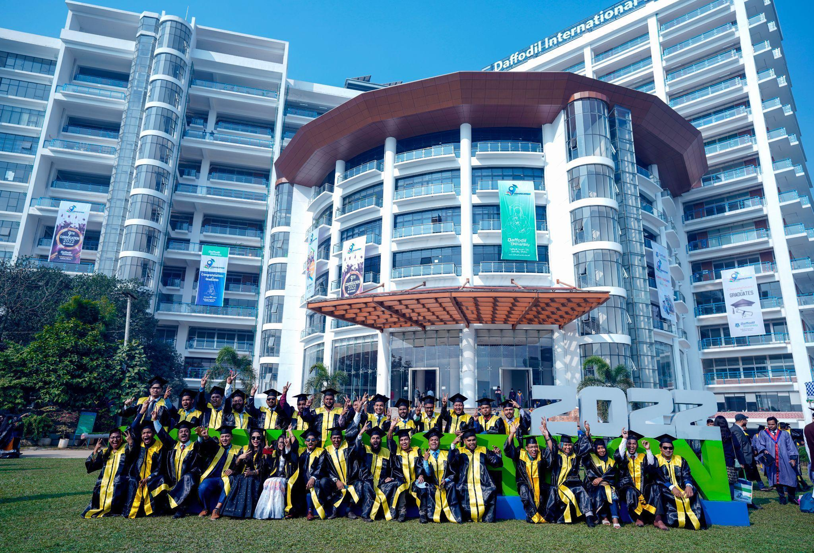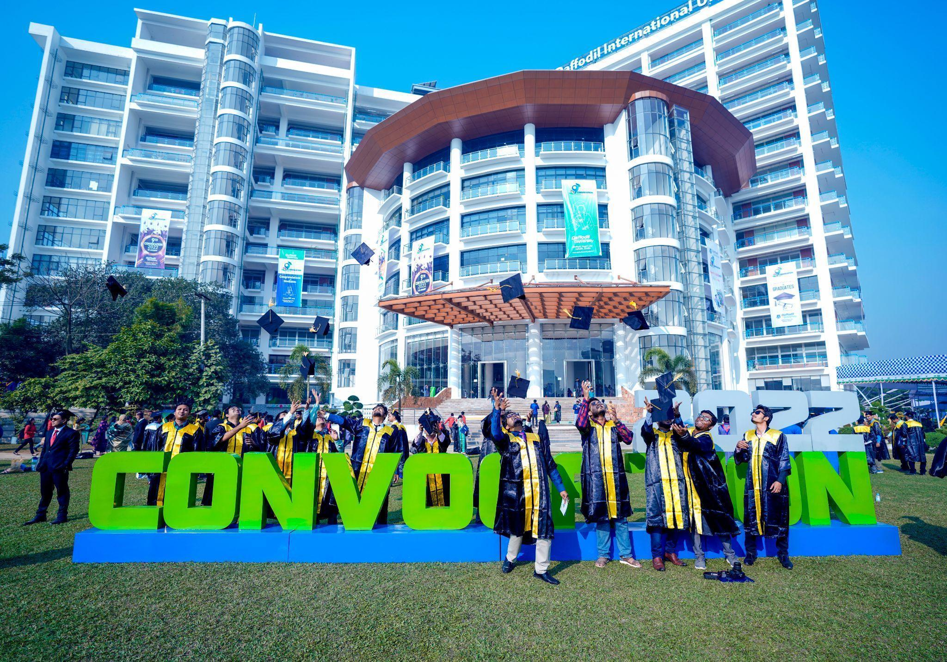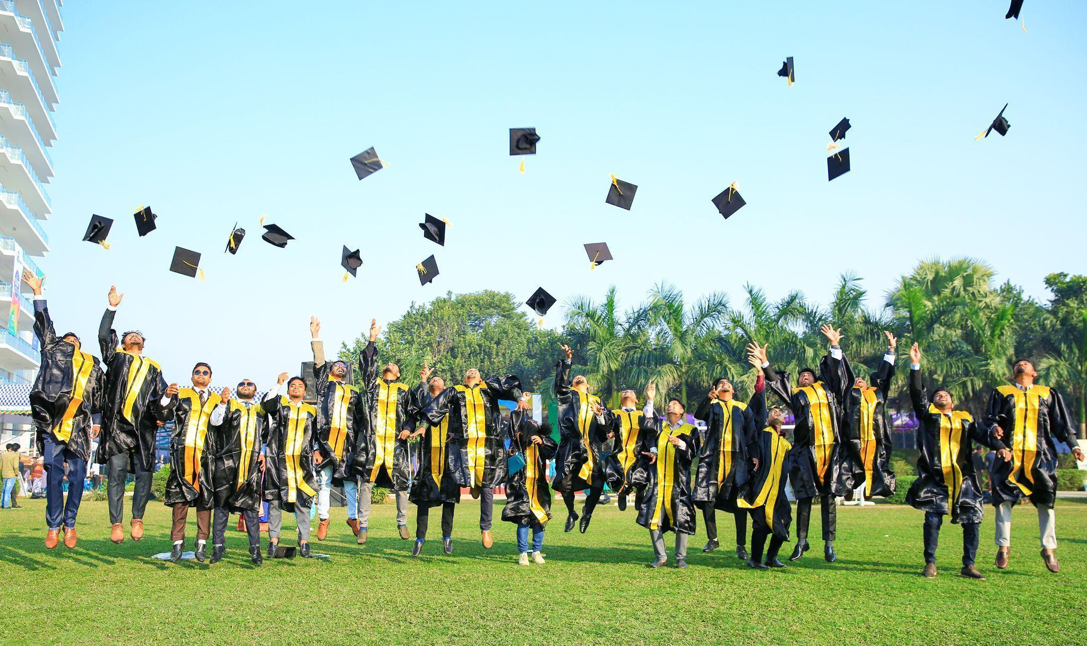

# 

# HIGHLIGHTS OF ‘DIU JOB UTSOB-2022’ *The fair will witness participation of highly acclaimed DIU graduates seeking internship and job opportunities.*

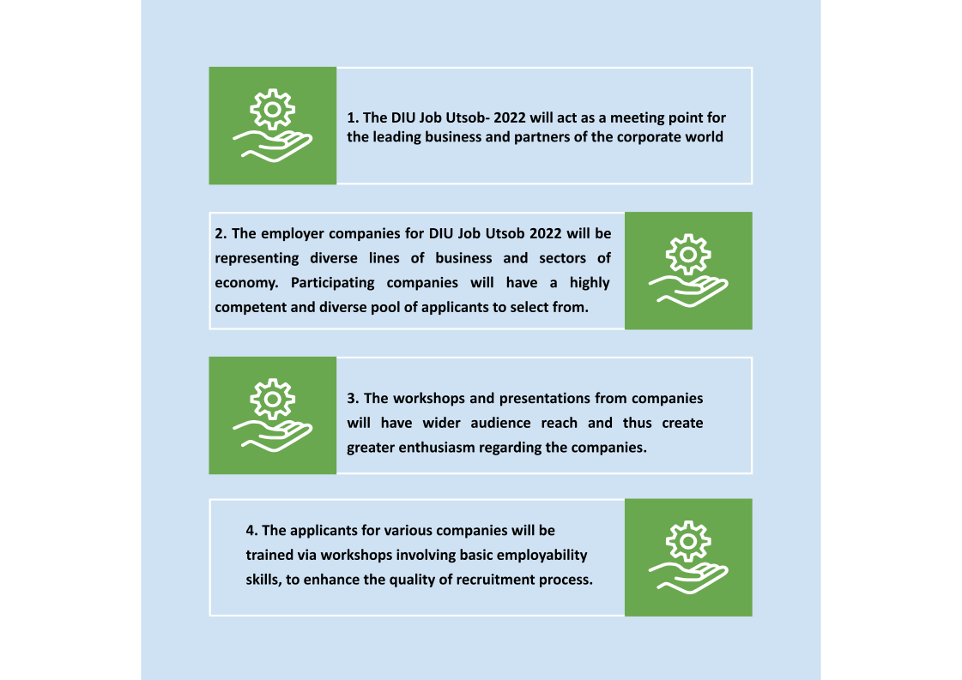

# 

# 

# 

# 

# 

# 

# PARTICIPANTS’ & PARTICIPATIONS DETAILS *The Fair will witness the participation of highly acclaimed DIU Graduates seeking internship and Job opportunities.*

DIU Job Utsob-2022 will be graced by the active participation of more than 4000 graduates from batches: 182,183 & 191 of Daffodil International University’s diversified 24 Disciplines and 44 programs under 05 faculties and also- skillful and technology enthusiast alumni seeking potential employment and placement opportunities, whereas the current students of the 9th-11th semester will participate in the event seeking internship opportunities.   
  
Approximately 2500 graduating students and 1500 graduates would be showcasing their industry-ready 21st-century employability skills and competencies through the event.  
  
**Please find the** [**DIU FACULTY & PROGRAM DETAILS**](https://daffodilvarsity.edu.bd/article/programs) **through the following link:**

https://daffodilvarsity.edu.bd/article/programs

**VISITORS SEGMENTS:**

* Candidates - employed, under-employed or unemployed - with professional qualifications looking for a job
* Candidates with experience and technical skills
* New graduates from 24 diversified disciplines and 44 programs under 05 faculties
* current students of the 9th-11th semester will participate in the event seeking internship opportunities 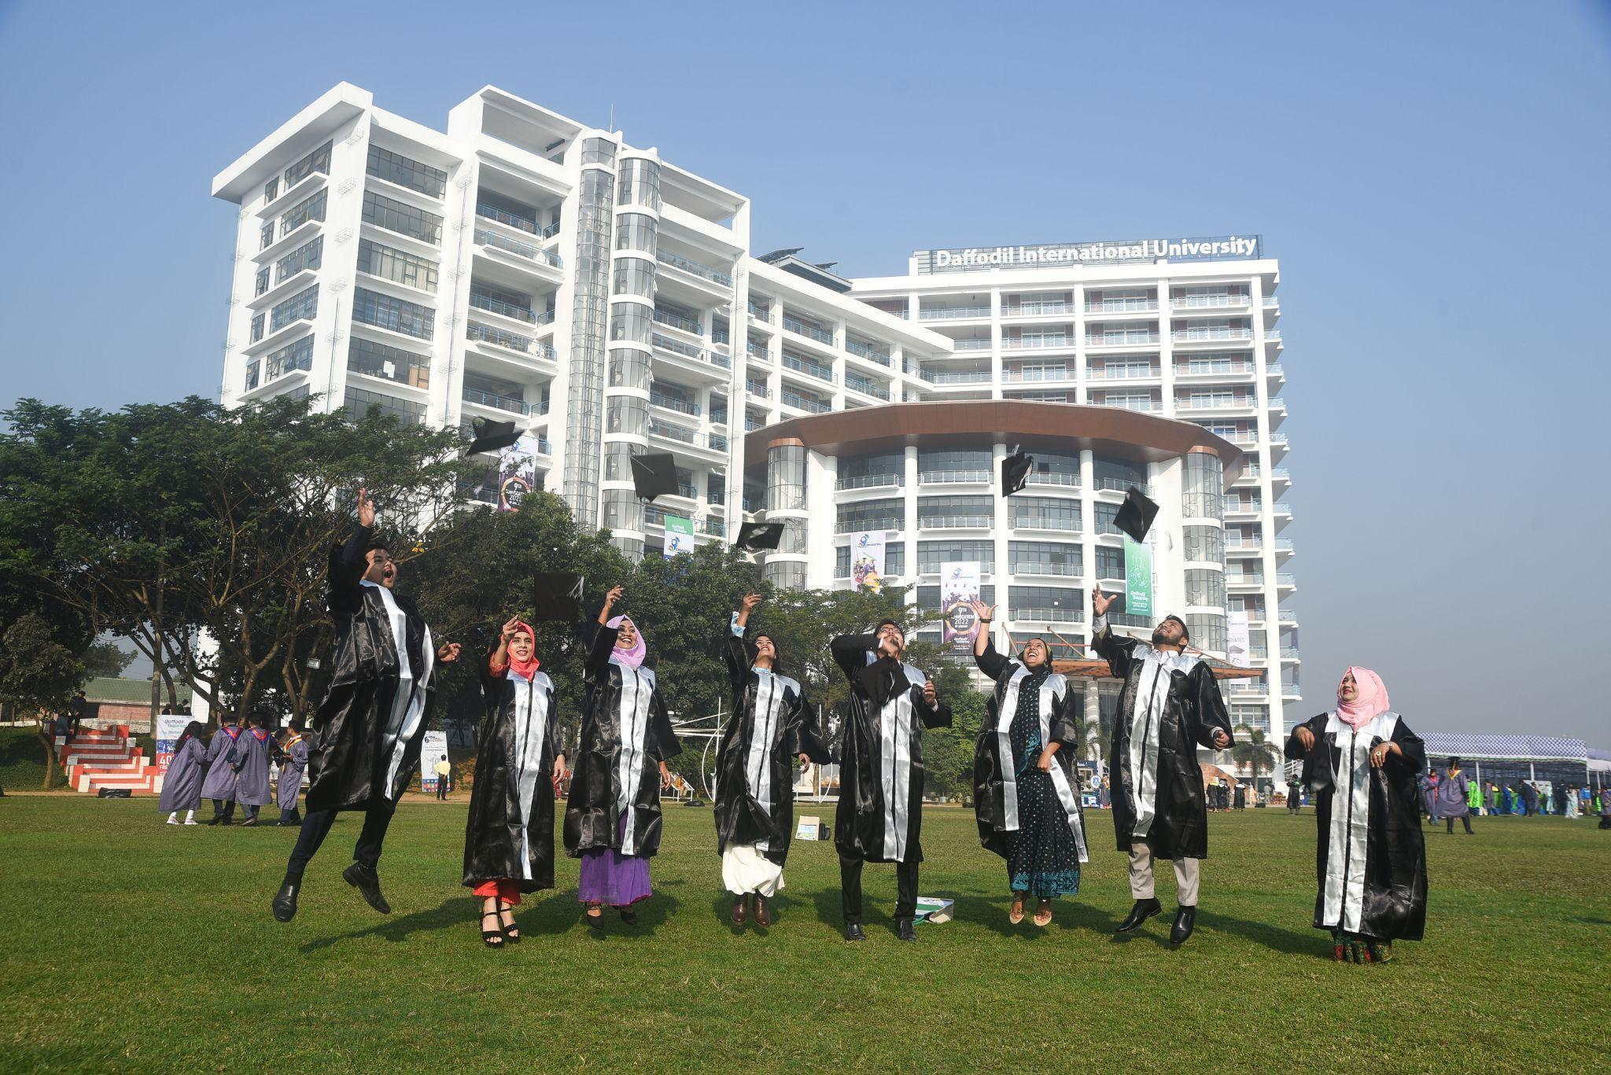
* Candidates looking for a second career
* Candidates in career transition
* Candidates looking to return to work
* Candidates attracted to self-employment and entrepreneurship

# 

# 

# 

# PROGRAM AND ACTIVITIES:

* Event Kick-off through Press Conference
* Grand Inaugural & Closing Ceremony
* Seminars/Workshop/Career Guideline Sessions
* Walk in Interview
* Resume Submissions
* **The Grand Exhibition:**   
  The 04 days long exhibition, running in parallel with the other activities, would provide job and employment showcasing opportunities for all industries. The exhibition initiative will provide a distraction-free networking environment to the exhibitors and will assist to become the definitive learning point and business gathering center also. 



The grand exhibition will be held at ‘Helmet’ at Daffodil Smart City (DSC) under the following zones-

1. Welcoming area
2. Sponsors area
3. Exhibitors Area
4. Walk-in-Interview Area

Besides these there will be a registration counter and information center at the entrance point of the venue.

# 

# 

# 

# 

# PARTICIPATION PROCEDURE *The procedures of DIU Job Utsob-2022 follow the following standard pattern and are designed to maximize the payoffs as an outcome of the event.*

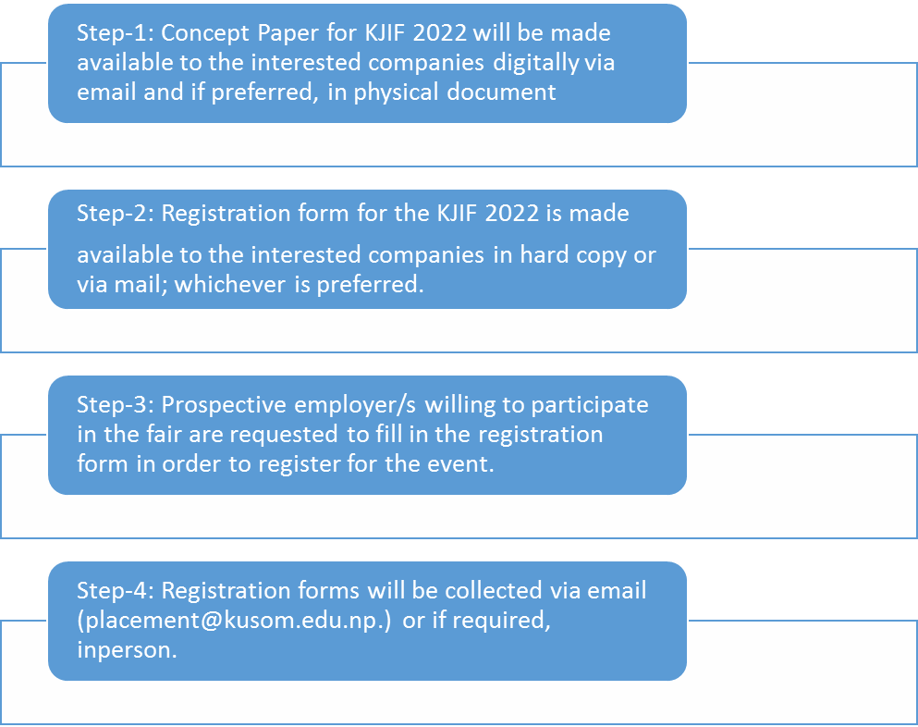

# WHY SHOULD SOMEONE JOIN/PARTICIPATE?

Because- DIU Job Utsob-2022 provides a unique opportunity for all stakeholders and it will be the handshaking point of the industry & the academia to assist our graduates to make the transition from campus to corporate.

Because- you shall participate and discover how career fests save time, logistics, and financial resources. Learn how we can be an active participant in your overall recruitment strategy. Being an exhibitor is filled with incentives there.

### Because- you will enter a world of mutual benefit.

Employers, trainers, educators, consultants, career services, and government services shall gather to meet the candidates and discover mutual benefits in the labor market.

### *Because- you will meet the future workforce of your organization.*

***Because- you will meet the experienced candidates according to your selection criteria.***

***Because- you will develop the largest network in the shortest time***

***Because- you will have an extensive and impactful advertising campaign.***

### *And….*

* Stimulate your recruiting and marketing teams.
* Promote your services and enhance your branding.
* Conduct or schedule interviews with preselected candidates.
* Analyze the strengths and weaknesses of your competitors.
* Build a large bank of qualified and available candidates.
* Do cross-promotions and special events with a higher impact.
* Team up with an organization recognized for its good business practices, professional ethics, quality client service, and friendly approach.

# 

# INTERACTION/RECRUITMENT PROCEDURE General Guidelines: *The further interaction/recruitment procedure will be as follows:*

# 

# 

# SESSION MATRIX

The Session Matrix of DIU Job Utsob-2022 will be published officially on 1st November,2022.

# EVENT FLOOR PLAN & EXHIBIT SPACE APPLICATION

# The Event Floor Plan & Exhibit Space Application will be published on 1st October,2022.

# OUR TEAM FOR DIU JOB UTSOB-2022

Our Team Banner will be published shortly with respective valued team members’ photographs & designations.

***EMPLOYER REGISTRATION FORM LINK  
FOR DIU JOB UTSOB-2022***

[**https://forms.gle/DiNkbkACp9zpSvxa8**](https://forms.gle/DiNkbkACp9zpSvxa8)

**DATES TO REMEMBER**

| Date | 01-04 December 2022 (Thursday - Friday-Saturday- Sunday) |
| --- | --- |
| Venue | Daffodil Smart City (DSC) Campus, Daffodil International University, Ashulia, Savar, Dhaka-1341, Bangladesh |
| Time | 09.30 am to 5.00 pm |
| Expected Visitor | 10, 000+ |
| Participating Organization | 200+ |
| Hosted By | Daffodil International University (DIU) |
| Event Organized & Managed By | CDC - Skilljobs, Spiral World, Employability360, GoEdu, and HRDI |
| Employers’ Registration Form Link | [**https://forms.gle/DiNkbkACp9zpSvxa8**](https://forms.gle/DiNkbkACp9zpSvxa8) |
| Last date of Stall Booking | 31st October 2022 |
| Confirmation for Sponsorship | 31st October 2022 |

# FOR MORE INFORMATION PLEASE CONTACT-

**Event Convenor/ Member Secretary**

DIU Job Utshob-2022

For sponsorship and stall booking, please contact at

01847334707,01713493162  
Email ID: [Jobutsob@diu.edu.bd](mailto:Jobutsob@diu.edu.bd)

**DIU JOB UTSOB-2022 EVENT FLYER (for Job Seekers Group)**

DIU JOB UTSOB -2022 is a celebration of gainful engagement in productive work in the industry and the social sector.

It will open a gateway for the companies to meet not only graduates for fresh recruitment but also the experienced alumni group of Daffodil International University for job-changing opportunities.

Job Utsob aims to help the fresher & job changers to find their dream jobs, the employers to find their suitable candidates - with the motto of *Connecting Talents :Unlock the Border of Opportunities*.

http: //jobutsob.daffodilvarsity.edu.bd

**Date: December 01-03, 2022 (Thursday-Friday-Saturday)**

**Venue: Daffodil Smart City (DSC), Ashulia, Savar, Dhaka-1341, Bangladesh.**

**Key Features of DIU Job Utsob-2022:**

* 03 days-long festival of wisdom, knowledge and job-readiness programs in which the participants & job seekers can face an interview with recruiters and can compete directly to win their deserved jobs.

.

* Approximately 4000 graduating students and 2000 passed-out graduates would be showcasing their industry-ready and job-ready 21st Century’s employability skills and competencies.
* **Event highlights:**
* 200+ booths of different companies
* 2000+ actual job openings
* 1000 internships
* 150+ actual recruiters.
* 50 National HR leaders’ session
* On campus interview
* Grooming session
* CV & video resume update
* Employability skill test assessment
* Valued employers (only initial confirmations, more to be finalized):

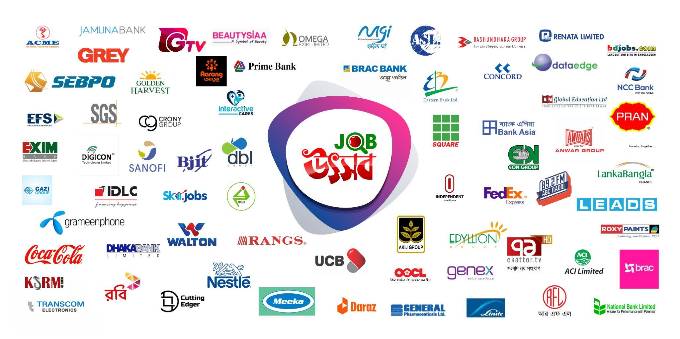

* **Who can join ?**
* Graduates from 182, 183 & 191 batches of all disciplines of Daffodil International University.
* Current students of 9th-11th semesters, for internship opportunities
* Passed out DIU alumni for job placement & job changing opportunities
* **Benefits to join**
* Job placement, internship placement & job changing opportunities in various renowned organizations
* Empower and accelerate your movement in career readiness with knowledge + Skills + attitudes imparted by the corporate leaders, trainers & career coaches
* Personal and professional branding opportunities
* Chance of HR networking and creating long term professional relationships with corporate leaders/speakers groups.

Before registration, **please update your CV** with following format [Link](https://drive.google.com/file/d/1Ab2gYB99niyImmEtaww6DF08mP6gsxYJ/view)

**Don’t miss the opportunity and hurry to register yourself clicking following Tab**

**Registration Form & QR Code:** [**Link**](https://backend.skill.jobs/jobutsob/alumni/)

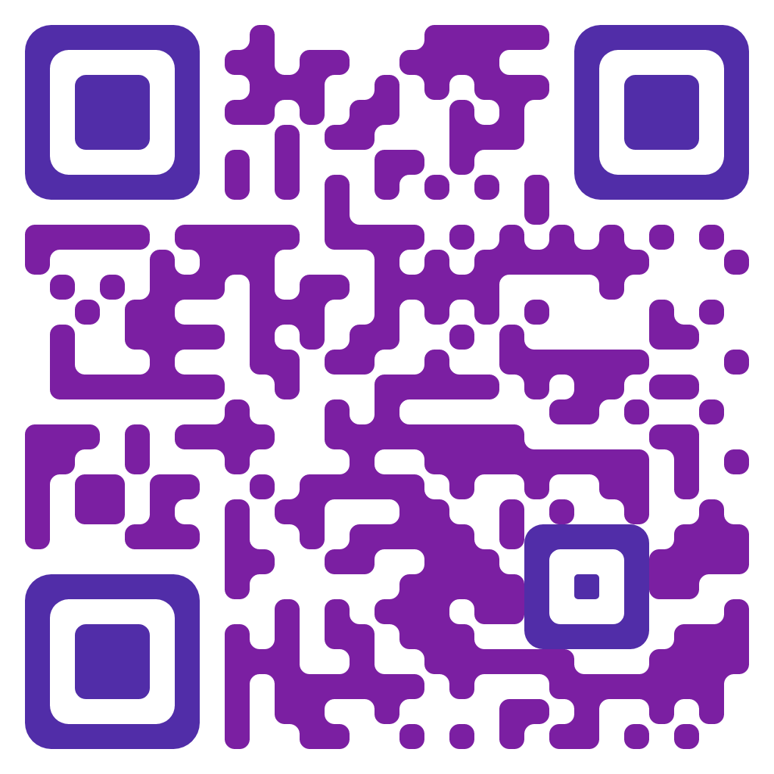

**DIU JOB UTSOB-2022 EVENT X Stand (for Job Seekers Group)**

**💢‘DIU Job Utsob-2022’💢**

**💢Daffodil International University (DIU) has designed an exclusive Big BANG Career event titled ‘DIU Job Utsob-2022’ with the tagline of ‘Unlock the Treasure of Opportunities’**

**💢Date: December 01-03,2022**

**Don’t miss the opportunity and hurry to register yourself scanning the following QR:**

**💢 Key Features of the Program:**

✅200+ Booths of Different Company

✅2000+ actual job Openings

✅1000 internships

✅150+ actual recruiters.

✅National HR Leaders Session

✅On Campus Interview

✅Grooming Session

✅CV & Video Resume Update

✅Employability Skill Test assessment

**Organized by DIU**

**Powered by CDC, Alumni Cell, Skill Job**

**Learning Partner: Goedu, HRDI**

**For Details Visit:** http: //jobutsob.daffodilvarsity.edu.bd

**💢Contact Us:**

**Career Development Center, DIU**

**Daffodil Smart City (DSC), Ashulia, Dhaka**

**Email: cdc@daffodilvarsity.edu.bd**

**Cell: 01847334705, 01847334706, 01847334707**